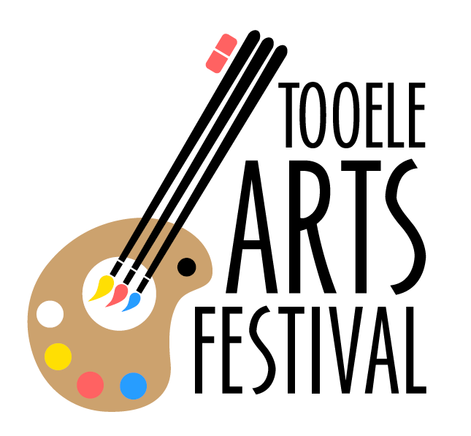
2018 TOOELE ARTS FESTIVAL
BATTLE OF THE BANDS – CONTEST RULES, REGULATIONS, AND SCORING CRITERIA

- Bands must complete an application (below), pay a $35 non-refundable application fee, and submit a song performance web link to Tooele Arts Festival by May 21.
  - Submissions must be sent electronically. Please e-mail ONE musical selection link to TooeleArtsFestivalEntertainment@gmail.com with subject line “Battle of the Bands Entrant.”
  - Application and signatures must accompany the electronic submission.
  - Payment can be made via PayPal at Tooele Arts Festival (tooeleartsfestival@gmail.com). Payment can also be mailed via check or money order to PO Box 826, Tooele, UT 84074.
  - Application, payment, and musical selection must be received by Tooele Arts Festival by 11:59pm, May 21.
  - Application fee is non-refundable under all circumstances, including weather and voluntary withdrawal from the competition.
  - Half of the entry fund money will be awarded to the winning band. The award amount is dependent upon the number of entries.
- Submissions will be posted online to be voted on by the public. The top 6 vote-getters will be chosen to perform at Tooele Arts Festival on Friday, June 15.
- Final performers (6) will be chosen by June 1. All bands will be notified of their acceptance or rejection on June 2 via e-mail. Please include a valid e-mail address on the submission application.
- Submission of musical selections and payment of entry fee is required but does NOT guarantee an opportunity to perform during the arts festival.
  - Submission merely guarantees that the band will be highlighted and eligible for votes on Facebook. Submission does not guarantee a spot on stage.
  - “Submission” consists of three parts:
    - Application/signatures
    - Electronic song performance (web link)
    - Payment
  - Entry will not be posted to Facebook online voting until all three portions of the submission have been received. This must occur by
- There is no limit to the number of bands who wish to enter the FB voting competition, and all submitted online demos will be posted online for possible selection.
- Finalist bands (6) must play four songs during their festival performance. Each band’s set must fill approximately 15 minutes but must not exceed 20 minutes.
  - If a band exceeds the 20 minute limit, five points will be deducted from their final score.
  - If a band agrees to play based on the rules set forth herein and then fails to do so, they will be immediately disqualified.
- All competing bands are strongly encouraged to share information about Tooele Arts Festival in the form of advertising, word of mouth, and social media sharing since crowd applause and reaction are part of the scoring matrix. Sharing information does not impact final score.
- Any distasteful behavior, and/or damage to Tooele City Park, stage, sound system, trailer, or other equipment in or around the venue, will result in an automatic disqualification at the hands of management and judges. Additionally, reimbursement for such damages will be sought.
- Judging is done on a 1-10 scale by three qualified judges. The four criteria on which the bands will be judged are explained below. The final criteria, however, will be crowd reaction. Bring your fans! “TIME OF DAY” CROWD SIZE WILL BE TAKEN INTO CONSIDERATION meaning that all bands will have the same consideration regardless of the time of day that they perform. The reaction of the available crowd will be considered, NOT the size of the crowd itself.
- A “Performer” consists of many different things. For this event, we require both instrumental and vocal performance. This means that an 8-piece group and a solo act will each be allowed as long as they sing and play at least one instrument.
- Neither Tooele Arts Festival nor Tooele City will be held accountable for any broken equipment, injuries, or any other negative occurrences.
- Tooele Arts Festival will provide the stage and sound system, but performers will need to provide their own drum mikes.
- Be prepared to set up and tear down quickly as only 10-15 minutes will be allotted for these tasks. Additionally, the bands scheduled before and after will also be setting up/tearing down at the same time. Cooperation and courtesy are expected.
- After the final judgements have been made, the winner of 2018 Tooele Arts Festival Battle of the Bands will be asked to play an encore performance on Saturday evening for 45 minutes. Please have a 45-minute set prepared in the event of victory. Material can be chosen at the band’s discretion (but must be family friendly).

Judging Scale and Criteria:
Category | Description | Maximum points available
Music | Based on clarity, lyrical content, overall musical performance | 10
Stage Presence and Crowd Interaction | Based on how well the band connects with the crowd | 10
Appearance and Personality | Based on personality as well as the overall look and how it fits with the music genre | 10
Crowd Applause | Based on crowd reaction | 20

2018 TOOELE ARTS FESTIVAL
BATTLE OF THE BANDS – APPLICATION
Date: _______________________

Performer/Band Name: _____________________________________________________
Performer/Band Genre: _____________________________________________________
Main Contact Name: _______________________________________________
Address, phone, e-mail: _______________________________________________
_______________________________________________
_______________________________________________
Band website: _______________________________________________
Band Members (all info required)
Band Member Name | Phone number | Age | Instrument/Vocal
(APPLICATION PAGE 1)
Submission fee paid by May 21, 2018, via
_____ Check _____ Money Order _____ PayPal
Name on account_____________________________

Agreement:
I ___________________________________________ (Band Member OR Band Member’s parent/guardian if under age 17), hereby declare that I have read the official rules and regulations of the 2018 Tooele Arts Festival Battle of the Bands competition. I declare that I am acting as representative for my entire band/ensemble. I declare that I (or we) will follow these rules during all competitions of said event. In agreement with Tooele Arts Festival, I also agree to submit to any penalty that is given to my band and I should I (or we) happen to break one of these rules.

Artist Release Agreement:
_____________________________________________ (Performer’s name) agrees to hold Tooele Arts Festival and Tooele City harmless from all claims arising from the use and promotion thereof in kind, of all kind whatsoever. Tooele Arts Festival does not guarantee or warrant any such claims to the success or failure of performer’s participation.

____________________________________________ (Band Member OR Band Member’s parent/guardian if under age 17) also warrants and represents that s/he is the sole legal owner of all right, title, and interest in all artwork including all related intellectual property interests such as trademarks and the sole and exclusive copyright in all artwork, and has the full right and authority to enter this agreement and grant the rights granted in this agreement.
The artist also represents that the display of the artwork on Tooele Arts Festival’s social media does not and will not infringe or violate the rights of any other party. This artist shall indemnify, defend, and hold Tooele Arts Festival harmless from any losses, claims, damages, penalties, or injuries occurred, including reasonable attorney’s fees, which arise from any claim by any third party of an alleged infringement of copyright or any other property right arising out of the display of artwork/music. The Artist understands that the display of artwork/music on the Tooele Arts Festival social media is subject to the sole discretion of Tooele Arts Festival and any or all of the artwork/music may be immediately removed from the multimedia sources at the sole discretion of Tooele Arts Festival.
I ___________________________________________ (Band Member OR Band Member’s parent/guardian if under age 18), grant Tooele Arts Festival the right to use my name, voice, image, biographical material, contact information – including details of my inability to complete the contract – on the Tooele Arts Festival website and social media accounts of any kind whatsoever.
(APPLICATION PAGE 2)

