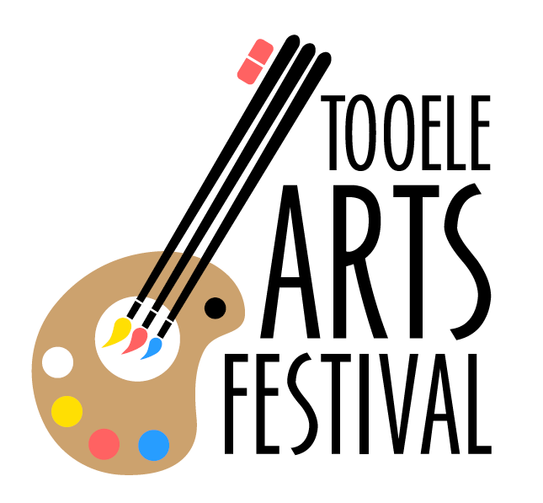
www.tooeleartsfestival.org 435-882-8282 P.O. Box 826 Tooele, Utah 84074
2021 Visual Artist Application for Fine Arts and Crafts
The 2021 festival will be held
September 17, 18, 19

Name: __________________________________________________________________
Address: _________________________________________________________________
City: ___________________________ State: _____________________ Zip: _________
Phone: _____________________________ Mobile: _______________________________
e-Mail: ___________________________________________________________________
How many booth spaces will you be requiring? _____________________
Category:
Ceramics Drawing Glass Jewelry Metalwork Painting

Photography/Artography Sculpture Wearable Art Furniture

2/3 Dimensional Mixed Media Wood \ Fiber Other

Description of art: ______________________________________________________________________________
_____________________________________________________________________________
______________________________________________________________________________
Acceptable Categories
Ceramics - All original clay/porcelain work – no machine made or mass produced work accepted.
Drawing - Crayon, charcoal, pencil, ink, chalk, pastel, wax crayon, inks/washes applied by pen or brush
Jewelry - Original handmade, high quality, limited quantities of like items. No commercial products allowed
Metalwork- Non-sculptured, non-jewelry metal work.
Painting- Oil, acrylics, watercolors, alkyd, pastel, tempera, other.
Photography/Artography- Prints made from artist’s original photo; must be properly signed and numbered. Computer generated pictures will not be accepted.
Sculpture- Three-dimensional original work done in any medium will be considered
Wearable Art- Leather, Fiber, metal and all handmade wearable work such as clothing, handbags, scarves hats, belts, and shoes. No mass production work will be accepted. No stamped items.
Wood- Original hand-tooled, machine-worked, or carved work
2/3 Dimensional Mixed Media- Art that uses more than one type of material to produce. Includes collage and hand-made paper; includes non-sculptural work. Abstract of unique quality.
Fiber – Work created from fibers such as basketry, embroidery, tapestry, weaving, leather, etc. No factory produced items or machine tooled/screened patterns allowed. No mass produced work accepted.
Glass – Hand blown, torched, kiln formed items. No mass produced work accepted.
Furniture- Original wood, metal or similar like items

Art Photos
Enclose or scan/e-mail four photos of your art no larger than 5x7
Write photo number, artist’s full name and category on the back of each photo
Photos must be high quality, all others will be returned.
Photo #1 Description:
______________________________________________________________
Photo #2 Description:
______________________________________________________________

Artist Fees
- A non-refundable application fee of $35.00 must accompany the photos, which must be received by August 1.
- Entries received after August 1 will be assessed a $10.00 late fee.
  - Late Entries will be considered based on availability of space and at the discretion of the selection committee.
- Acceptance or non-acceptance will be provided to you by:
  - August 15 if your application is submitted before August 2
  - August 31 if your application is submitted August 2-17
  - Case-by-case basis if your application is submitted August 17 or later
- If accepted, a booth fee of $140 is due by September 1.

Artists Location and Designated Hours
Festival will be held at the Tooele City Park located:
200 West Vine Street
Tooele, Utah 84074
Booth set-up is 3pm-10pm on Thursday AND 7am-10am on Friday. NO VEHICLES on festival grounds after 10am on Friday.
Please check in with Visual Arts Coordinator for booth location/assignment. Visual Arts Coordinator will be found at the information booth located in front of the pavilion on the west side of the park.
Festival hours and Visual artist expectations are as follows:
DATE | FESTIVAL HOURS | ARTIST EXPECTATIONS
Thursday, Sept 16 | Booth Set Up | 3pm-10pm – artist’s discretion
Friday, Sept 17 | Booth Set Up  Festival begins | 7am-10am – artist’s discretion. (NO VEHICLES on festival grounds after 10am)  12am*-8pm**
Saturday, Sept 18 | 10am-10pm | 12pm*-8pm**
Sunday, Sept 19 | 10am-5pm | 10am*-4pm**
* Artists can open booths and sell as early desired; however, booths MUST be open by time indicated above.
** Booths are not required to be open after 8pm, but artists can expect some foot traffic between 8pm-10pm and can sell during this time.
Misc. Information
Need electricity. (Please provide your own 50 ft. heavy duty electrical cord.)

Booth Sitter required? Information will be provided at check in. Booth sitters are available in ten minute increments and will not conduct sales on artist’s behalf.

Will you be sleeping in your Booth Overnight? We will provide a special sign to alert security.

Have you participated in other festivals? Yes / No
If yes, where?
______________________________________________________________________

Rules and Expectations
- All art must be product of the accepted artist who must be present during the festival.
- The booth size is 10x10 ft. and requires a WHITE canopy. Any exception to this rule will be determined by the Visual Arts Committee. We do not accept blue or any other color canopy. A limited number of white canopies are available to rent from the Tooele Arts Festival for $25 per day.
- You may request more than one booth space; however, you must pay an additional $135 for the second space.
- You may share a booth with another artist. However, the other artist must also submit an application, application fee and pictures. Each entry will be judged on its own merit and must be indicated on the application form.
- You cannot sell any candy, food, drinks (including bottled water) and you cannot fill jars, boxes, bottles, etc. with any other type of food. These items will be removed from your booth.
- Previous participation in Tooele Arts Festival does not guarantee that you will be allocated or have the same space as previous year(s).
- You are welcome to make special requests on your application, but unless it is of critical nature, we ask that you please accept your assigned space.
- The committee (jury) will be reviewing on a daily basis to ensure that no commercial/mass produced items are displayed. We realize this action benefits you as an artist as well as allows the committee to produce a quality festival. If any item is deemed not adhering to the rules, the item(s) will be removed from your booth AND/OR you may be asked to leave the festival with no refund of booth or application fees. Additionally, this will jeopardize your chance for consideration in future festivals.
- The Tooele Search & Rescue Unit will provide on-site security from Wednesday evening through Saturday morning. However, this does not constitute a guarantee that there will be complete security coverage. Additionally, NO security will be provided after 11pm on Saturday night. All art should be removed from booth or appropriately secured. All art is the responsibility of the artists; Tooele Arts Festival assumes NO responsibility or liability for art at any time.
- For weather conditions and additional security, you must “wrap” your canopy each night and it must be FIRMLY secured to the ground. (Sand bags and/or concrete blocks, and anchors are strongly recommended.)

**Please direct questions to: Terri at 435-313-4851.

Application Submission
Return completed and signed application, pictures, and application fee to:
Tooele Arts Festival
c/o Visual Arts Director
P.O. Box 826
Tooele, UT 84074
email: tooeleartfestivalvisual@gmail.com
I have read the application and agree, if accepted as an exhibitor, to abide by all decision and regulations of the 2021 Tooele Arts Festival. I verify that items displayed in my booth are my original work or identified as a reproduction of my work. I understand that I am subject to daily review to ensure this statement is valid.
I hereby release and forever discharge the 2021 Tooele Arts Festival and its organizing committee, the City of Tooele, all sponsoring organizations, and volunteers from any responsibility, personal liability, claims, loss or damage arising out of or in conjunction with my application to the 2021 Tooele Arts Festival.
Signature: _________________________________ Date___________

